Russian Roulette



**6 player game**

Things needed: 6 cards

Objective: The player who eventually has a bullet card in his hand loses the game.

1. After shuffling six cards, each player takes one card each. They are able to take a peek at their cards (DON’T SHOW THEM TO OTHERS!)
2. Each player go around and can choose whether they are going to trade their card or not. However, if the previous player does not trade their card, the next player must trade.
3. After all the trades are done, all players expose their cards by flipping them around. The one with the “bullet card” loses the game, and must face punishment.

Laser Field

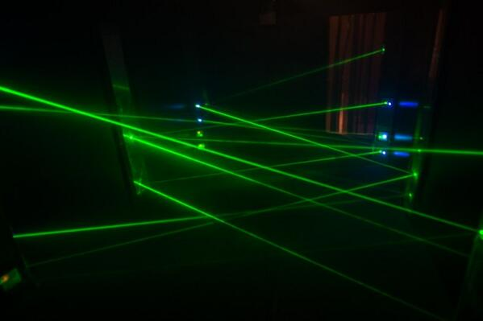

**2 Player Game**

Things needed: A paper and a two pen with different colors(red and blue)

Objective: The player who draws a line over the opponent’s line loses.

1. First, both players draw ten dots each anywhere on paper.
2. One player picks any dot and draws a line that connects with the other dot. The next player does the same.
3. For every turn, both players must start from the dot they’ve arrived last turn. They should not start again from a different dot.
4. After surviving four turns, both players can add one dot each anywhere in the space.
5. The player who cuts through other’s line loses the game. However, it is okay to cross their own lines.

How To Make **Spaghetti alle vongole**

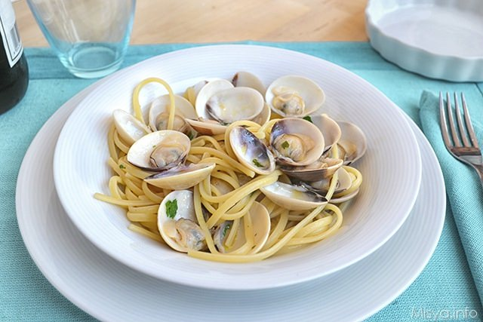

Ingredients: 100g of spaghetti, 2lbs of Manila clams, Plenty of garlic and dried chili pepper, Olive oil, white wine(cooking), salt and pepper, parsley.

1. Boil water, and put 100 grams of spaghetti into boiling water. If the spaghetti is well cooked, transport spaghetti into the strainer to remove water.
2. Locate the spaghetti into an aluminum plate.
3. Add some olive oil (not excessively!) Mix the pasta with olive oil to make it
4. Chop some garlic into thin pieces.
5. Grind small amount of dried chili pepper into bits.
6. Turn on the fire, and place a pan. Add olive oil.
7. Put pieces of garlic and pepper into the pan.
8. Add Manila clams into the pan.
9. For enhanced fragrance and taste, add white wine.
10. ‘/Put another pan and cover the top. Let it simmer.
11. After it’s boiling, add some spices(pepper and parsley)
12. Add small amount of water, and then put spaghetti into the pan.
13. After cooking, locate spaghetti and clams onto a plate.
14. Decorate and enjoy!

**Draw Justin’s Character!**

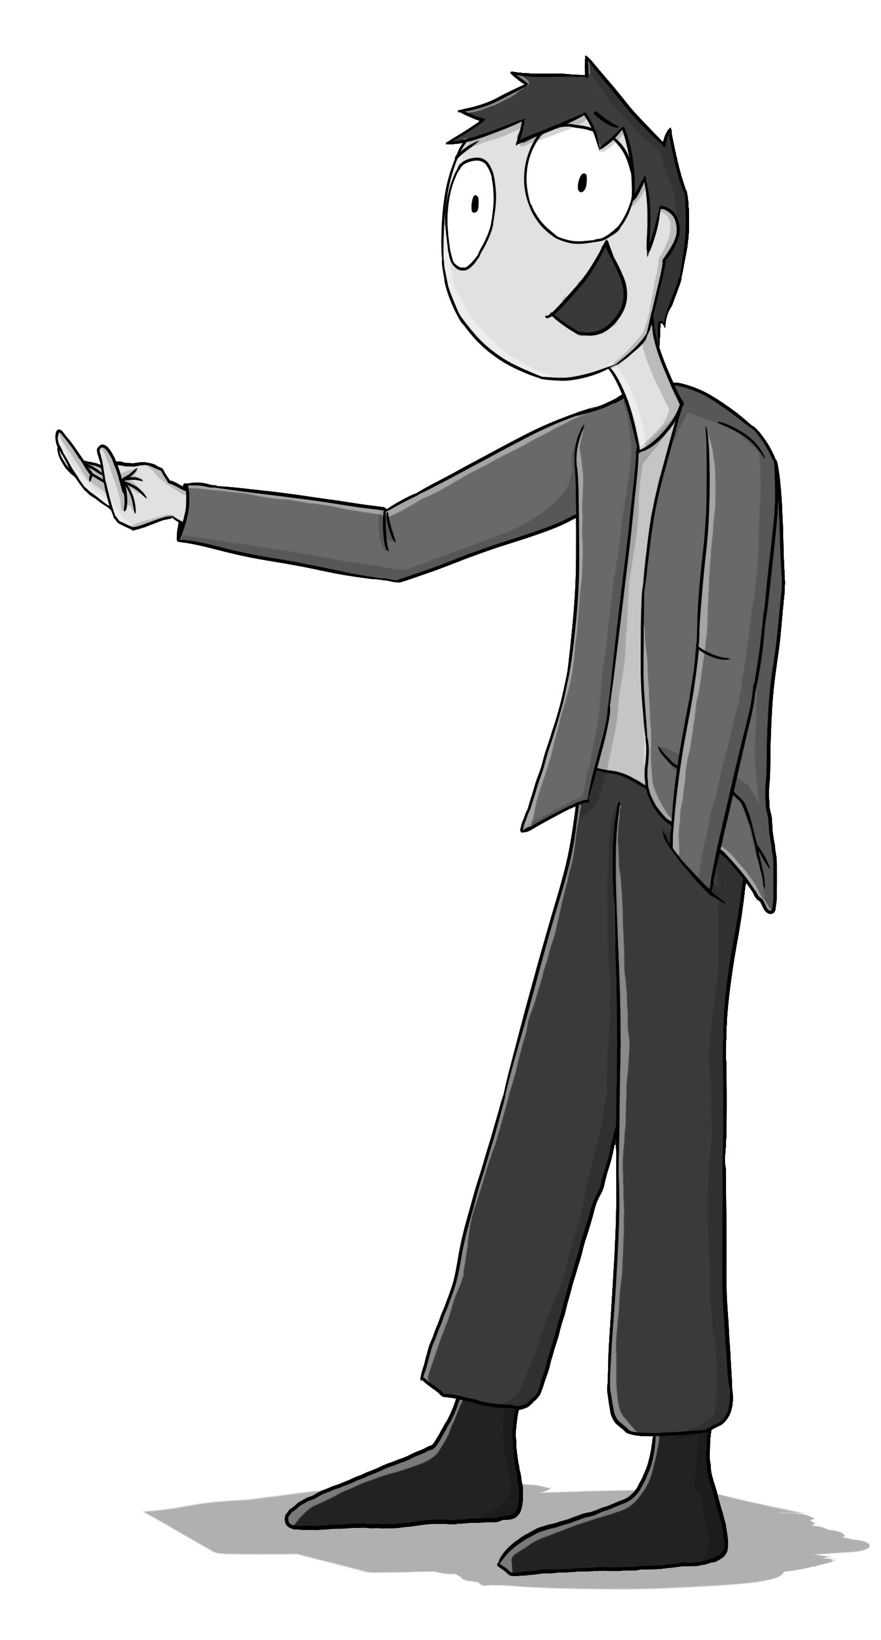

1. Draw a circle for the head. Draw a soft cross to illustrate the direction where the head is looking.
2. Draw a thin, cylindrical neck right beneath the head.
3. Draw the body, starting from the thin shoulders. Extend the arms until it reaches his hands. Add two curvy lines to suit him a hoodie. Add a blob behind the character’s neck for the hood.
4. Draw hands under the sleeves(1/3 size of head)
5. Draw legs. Just imagine having two rectangles with similar lengths as the upper body.
6. Provide some shoes. Easily draw right-angled triangles under his jeans.
7. The face is still empty. Draw the hair. The hair points towards the left, and add some curvy spikes on top.
8. Draw two squashed circles for the eyes. Then, poke two dots to decide his viewing direction.
9. The character does not have a nose (he actually does, but it’s obscured). Draw a square towards the side of the face. This is the mouth.
10. Just for better quality, shade the character’s hoodie. Shade the hair even darker.

How to beat Super Mario Bros.

in 10 minutes!!

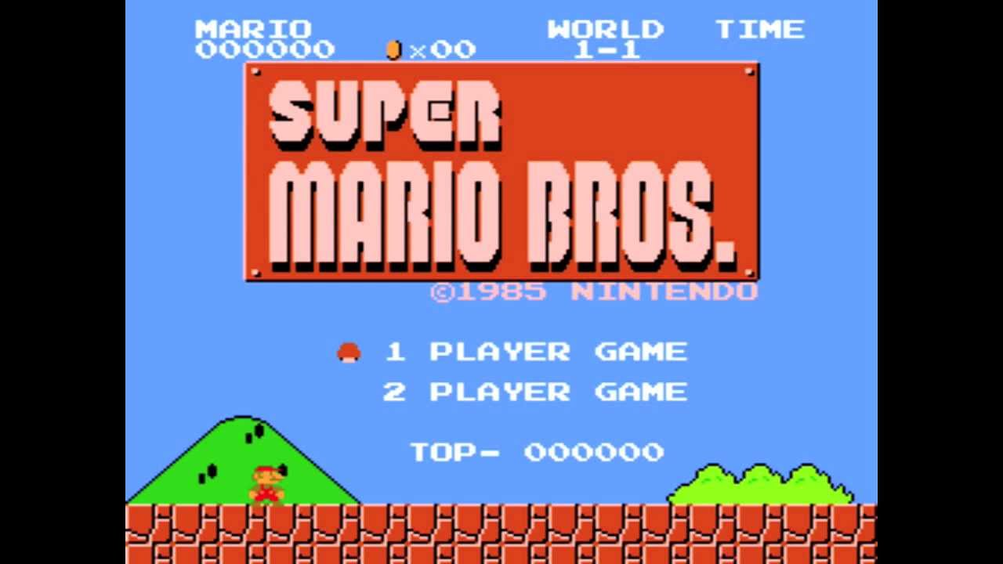

1. Start the game. The fourth pipe is a shortcut to the near end of **World** **1-1**. Go into this pipe and collect lots of coins!
2. In **World** **1-2**, the ceiling is covered with blocks. This can be crushed through. Use elevating objects or high terrains to crush through the ceiling. Run towards the far end until you see a hidden room with three pipes labelled: **4**, **3** and **2**. Enter pipe number **4**. This warps you to **World 4-1** immediately.
3. **World** **4-1** has no efficient shortcuts, unlike **World** **1-1**. Just run to the right as quickly as possible. Running with looking back is easier for you to not get hit by falling spiky turtles.
4. Enter **World** **4-2**. Right after passing the elevating steps, there are transparent, hidden blocks right above Mario’s head. If you see three connected brick blocks, the first block contains a long vine that takes you to a hidden palace. Jump under the middle block to expose a hidden block, and then jump again right under the right one that’s located right beside the hidden block you’ve found. Go up those blocks and successfully hit the left brick block that contains the vine. Go up!
5. You’ll find yourself in a palace with full of oddly flat mushrooms. Go to the far right and enter the space with three pipes labelled, **8**, **7** and **6**. Enter pipe **8,** which will take you to world 8-1.
6. There are not efficient shortcuts until **World** **8-4**. After entering **8-4**, find the first pipe you see and enter that pipe. The pipe will warp you to a terrain with more pipes. Go straight until you see a pipe floating on air. Hit the hidden block that’s on the lower left side of the pipe, and enter this pipe. After being warped, go straight and pass two pipes. The next pipe is the one you should enter. Beware of the flying fish! You’ll be warped to an underwater terrain. Evade all obstacles and enter the pipe at the far end. You’ll then be warped right on front of Bowser (the boss).
7. Reach the axe and drop Bowser into the lava.